**Practical No. 01**

**Aim:**

### **a). Using Variables in PL/SQL**

### **b. Writing an Executable PL/SQL Statement**

**C. Create anonymous PL/SQL**

### **D. Working with Sequences**

### 

### 

### 

### 

### 

### 

### 

### 

### 

### 

**Name: Sibaraj Lenka**

**Class:FYBScIT(A)**

**Roll No.:58**

**Subject: Procedural Language extensions**

**to the Structured Query Language**

**Sign:**

### **a). Using Variables in PL/SQL**

**Input:**

Set Serveroutput on;

DECLARE

v_emp_id NUMBER := 100;

v_emp_name VARCHAR2(50) := 'John Doe';

BEGIN

DBMS_OUTPUT.PUT_LINE('Employee ID: ' || v_emp_id);

DBMS_OUTPUT.PUT_LINE('Employee Name: ' || v_emp_name);

END;

**Expected Output**:

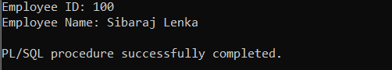

### **b. Writing an Executable PL/SQL Statement**

**Input:**

Set serveroutput on;

DECLARE

x NUMBER := 10;

y NUMBER := 20;

z NUMBER;

BEGIN

z := x + y;

dbms_output.put_line('Sum is '||z);

END;

**Expected Output:**

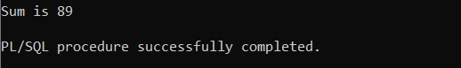

—------------------------------------------------------------------------------------------------------------------

**C. Create anonymous PL/SQL**

**block,**

**Example**:

Set serveroutput on;

DECLARE

-- declare variable a, b and c

-- and these three variables datatype are integer

a number;

b number;

c number;

BEGIN

a:= 54;

b:= 45;

--find largest number

--take it in c variable

IF a > b THEN

c:= a;

ELSE

c:= b;

END IF;

dbms_output.put_line(' Maximum number in 54 and 45: ' || c);

END;

/

**Expected Output:**

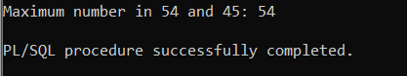

### 

### **D. Working with Sequences**

**Example**:

Set serveroutput on;

CREATE SEQUENCE emp_sequence START WITH 1 INCREMENT BY 1 NOCYCLE CACHE 10;

CREATE TABLE employees (

employee_id NUMBER PRIMARY KEY,

first_name VARCHAR2(50),

last_name VARCHAR2(50),

hire_date DATE

);

DESCRIBE employees;

-- Insert Employee 1

INSERT INTO employees (employee_id, first_name, last_name, hire_date)

VALUES (emp_seq.NEXTVAL, 'John', 'Doe', SYSDATE);

-- Insert Employee 2

INSERT INTO employees (employee_id, first_name, last_name, hire_date)

VALUES (emp_seq.NEXTVAL, 'Alice', 'Smith', SYSDATE);

-- Insert Employee 3

INSERT INTO employees (employee_id, first_name, last_name, hire_date)

VALUES (emp_seq.NEXTVAL, 'Bob', 'Johnson', SYSDATE);

SELECT * FROM employees;

**Expected Output:**

